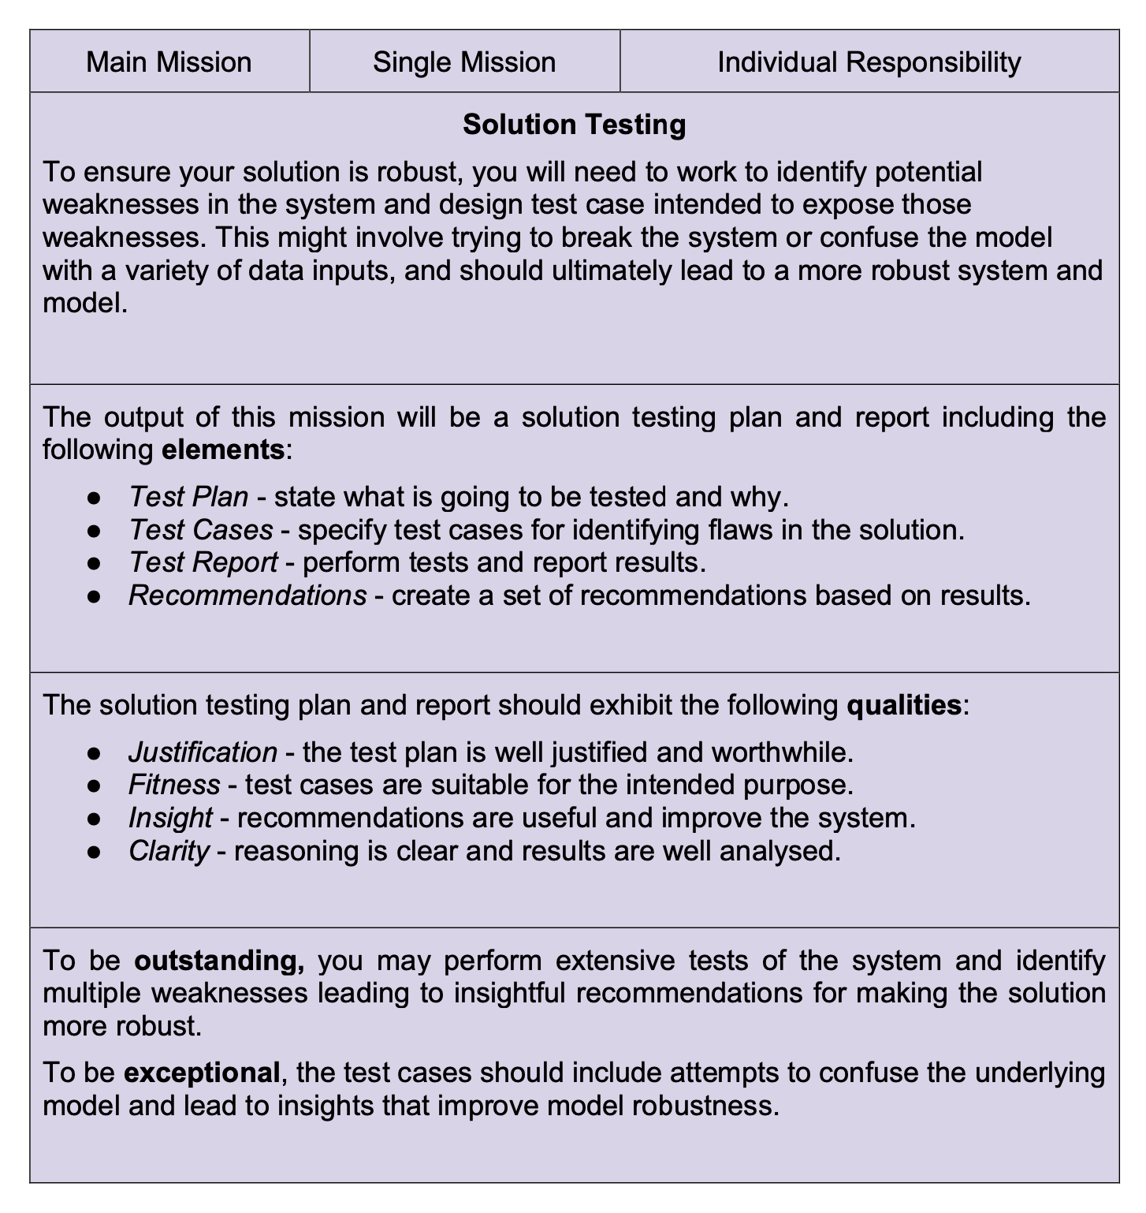

1. **Introduction**

This report presents the process of analyzing and testing the performance of an AI (Artificial Intelligence) application designed to recognize American Sign Language (ASL) and provide text output for children learning ASL. The AI application accepts video input and uses advanced machine learning algorithms to interpret ASL signs and convert them into text. Children who are deaf or find it hard to hear can learn and interact with others with the help of this breakthrough AI programme. However, it is essential to verify that the AI application can reliably and accurately identify ASL signs in a variety of situations. As a result, this report's goal is to offer a thorough solution testing strategy and report for the AI application to spot any potential flaws and make suggestions for improvements that will improve the system's speed and resilience. This report will include insightful analysis and suggestions for improving the precision, speed, and user experience of the AI application through extensive testing and analysis.

1. **Test Plan**

The goal of this test plan is to confirm the accuracy and dependability of the AI application created to recognize American Sign Language (ASL) and provide written output for kids learning ASL. The report will cover tests that examine how the AI application performs in various environments by inputting different scenarios. The tests will evaluate different attributes such as signs, speeds, lighting conditions, and backgrounds to determine whether the AI application can accurately recognize ASL signs in diverse contexts. The objective of this test is to assess the application's ability to perform consistently and reliably in different scenarios. The following steps describes how the testing would be carried:

1. Prepare the testing environment and tools, including the video camera and software.

2. Set up the AI application on the computer.

3. Run the scenario in the ai application.

4. Record the scenario and the response of the AI application.

5. Analyze the test videos to compare the actual ASL signs with the output text generated by the AI application.

6. Record the results of each test case and summarize the findings.

7. Analyze the test results to identify any patterns or trends in the data and identify any strengths and weaknesses of the AI application.

8. Make recommendations for improving the AI application based on the test results.

This test strategy will help us make sure that the AI application has been thoroughly evaluated to find any potential flaws and offer suggestions for enhancing its performance and robustness.

1. **Test Cases**

**III.I. scenarios description**

The AI application's performance was tested in three different scenarios to assess its ability to recognize American Sign Language signs accurately in diverse environments.

The first scenario was carried out in a well-lit environment (library) which is the ideal lighting condition to make detecting hands simpler for the ai application, with a background that has variety of objects (computers, chairs, desks and other students).

The second scenario was carried in a low-light environment(bedroom), with a simple background (wall) which is an ideal background that would make detecting my hand easier for the ai application because there are few objects the ai application could focus on. The third scenario was in a well-lit environment (lab), with a simple background (wall), which is the ideal background environment and lighting condition the AI application could detect the hand movement. These asl signs were performed in different speeds (slow, medium, fast) in each scenario, to test the accuracy of the AI application in different contexts. The asl signs that been picked to be tested in these scenarios are random and from different classes in the AI application including letters, numbers and phrases which are A, B, W, R, 0 and I love you.

**III.II.** **The expectation**

1. The first scenario was designed to test the AI application's ability to detect hand movement accurately in a well-lit environment with a complex background containing various objects. is expected that the AI application would accurately recognize the ASL signs in this environment.

2. The second scenario was designed to test the AI application's ability to detect hand movement accurately in a low-light environment with a simple background. In this case it is expected that the AI application would not be able to recognize the ASL signs accurately even if the background is an ideal condition.

3. The third scenario was designed to test the AI application's ability to detect hand movement accurately in an ideal scenario (well-lit environment with a simple background). It is expected that the AI application would accurately recognize the ASL signs in this ideal environment for hand detection.

1. **Test Report**

**IV.I results**

**1. The first scenario**

In this scenario, the AI application performance was mediocre, The AI application was able to detect 3 out of 6 signs, this table present the results I obtained:

|  |  |
| --- | --- |
| Asl signs | Scenario 1 |
| A | positive |
| B | negative |
| W | positive |
| R | negative |
| 0 | negative |
| I LOVE YOU | positive |

The AI application was able to detect the asl signs for (A, W, I love you) straightforwardly:

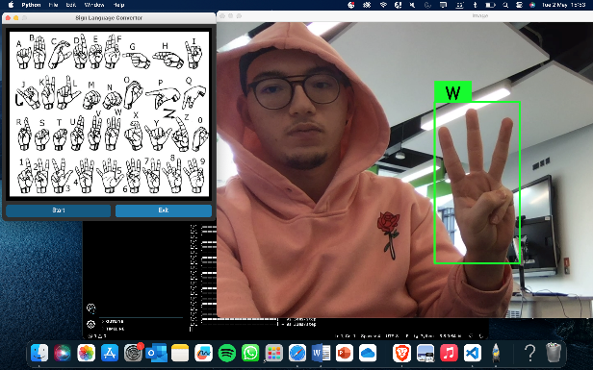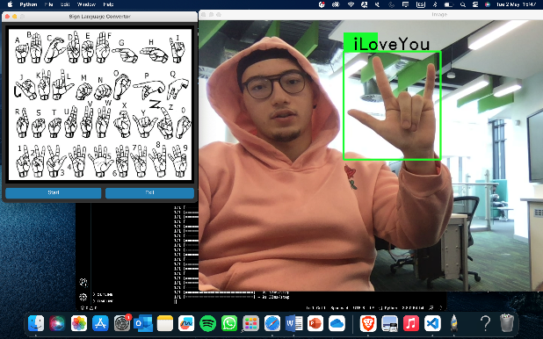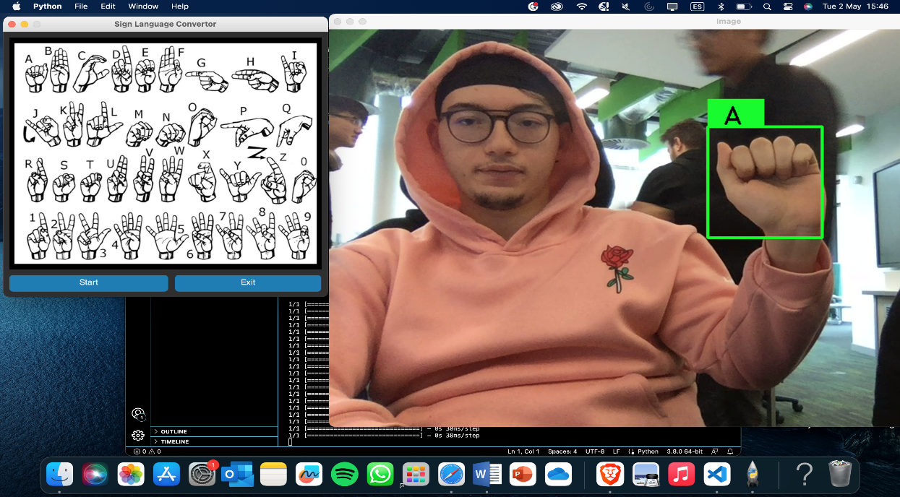

However, the software was mistakenly labeling the asl sings, for example the ai application find it hard to label asl sign B with the right label, ai system kept displaying the letter W as label for B:

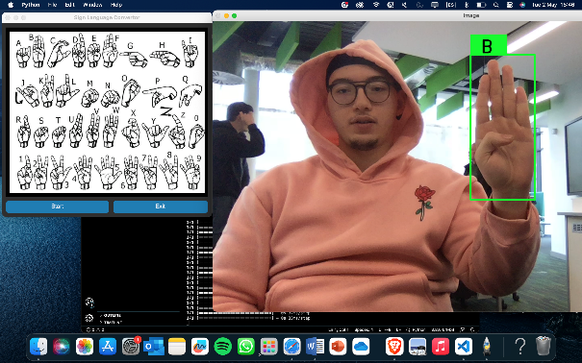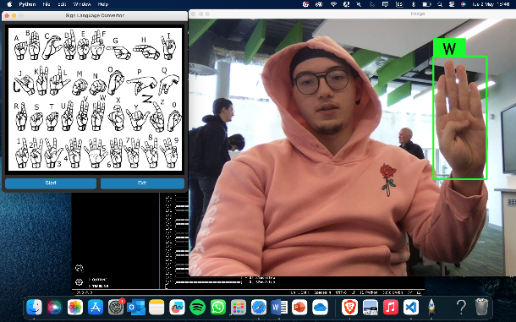

The same happened with the asl sign that signifies R and 0, both signs were never assigned the right label:

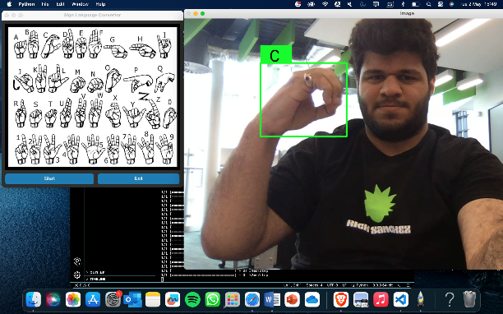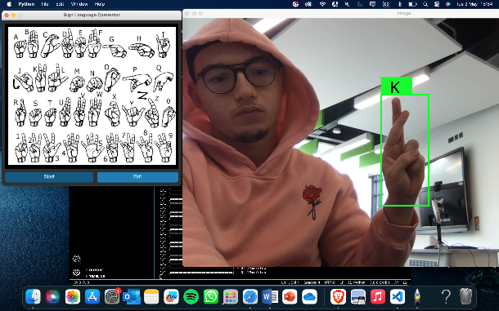

**2. The second scenario**

In the second scenario, the AI application performance was mediocre as well, The AI application was able to detect 3 out of 6 signs, this table present the results I obtained:

|  |  |
| --- | --- |
| Asl signs | Scenario 2 |
| A | positive |
| B | negative |
| W | negative |
| R | positive |
| 0 | negative |
| I LOVE YOU | positive |

The AI application was able to detect the asl signs for (A, R, I love you) directly:

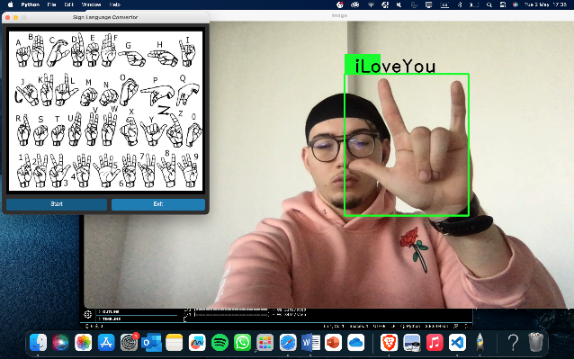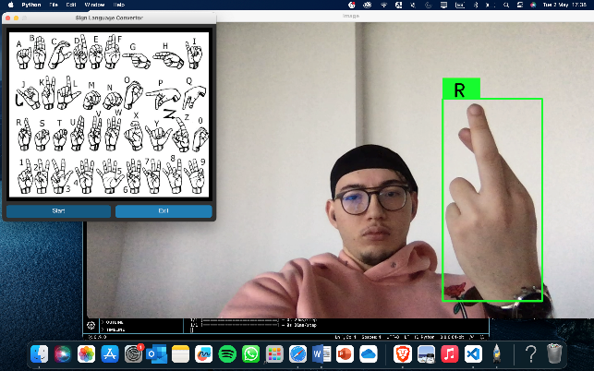

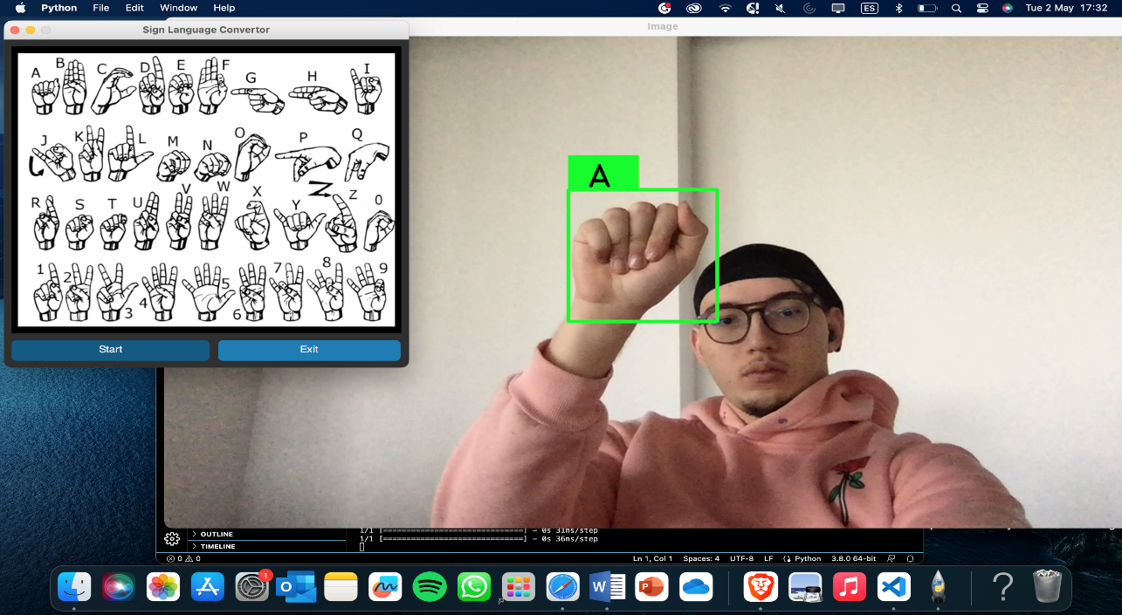

However, the software was mistakenly labeling the asl sings, for example the ai application find it hard to label asl sign 0 with the right label, ai system kept displaying the letter C as label for 0:

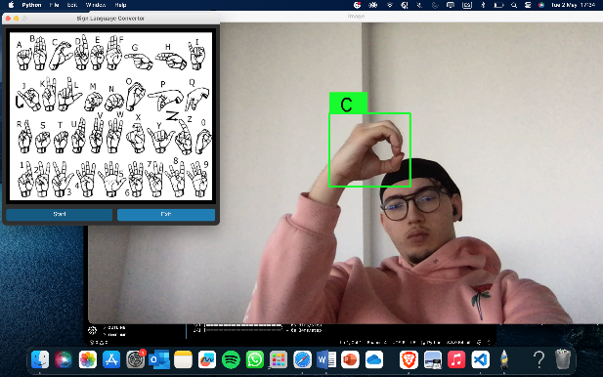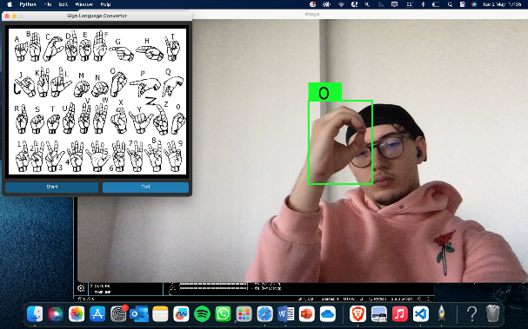

And the same happened for letters that symbolize B and W:

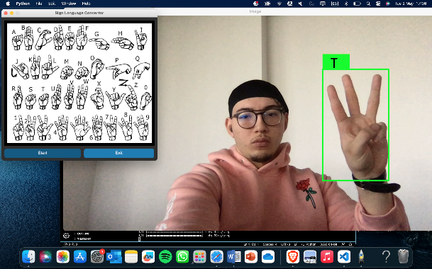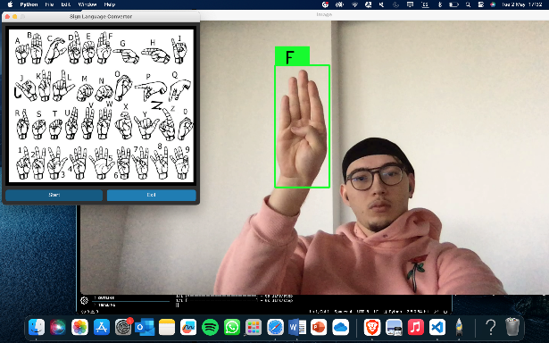

**3. The third scenario**

In the third scenario, which is the ideal situation, the AI application performance was outstanding, The AI application was able to detect 5 out of 6 signs, this table present the results I obtained:

|  |  |
| --- | --- |
| Asl signs | Scenario 3 |
| A | positive |
| B | positive |
| W | positive |
| R | positive |
| 0 | negative |
| I LOVE YOU | positive |

The AI application was able to detect the asl signs for (A, W, B, R and I love you) easily:

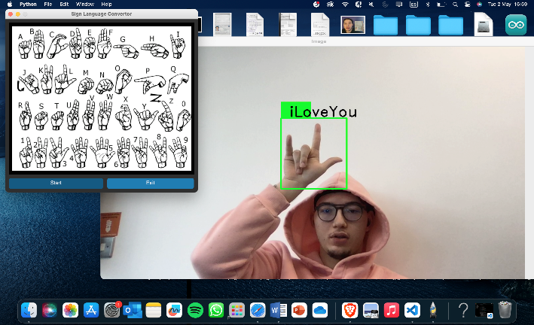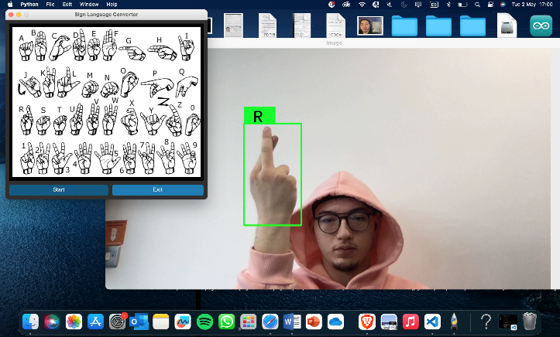

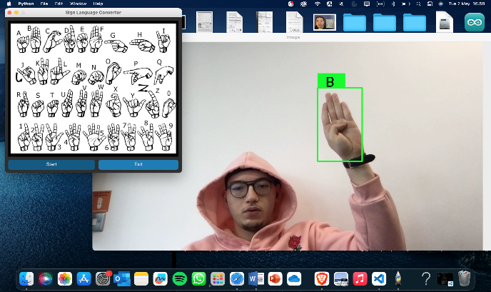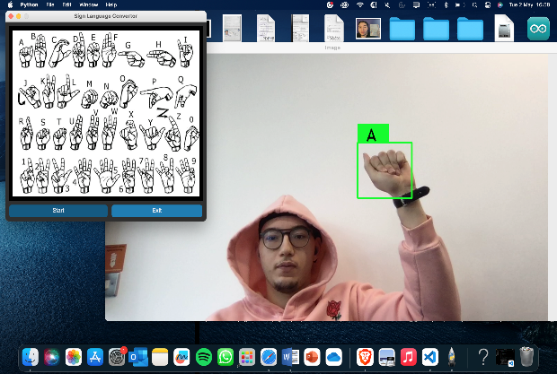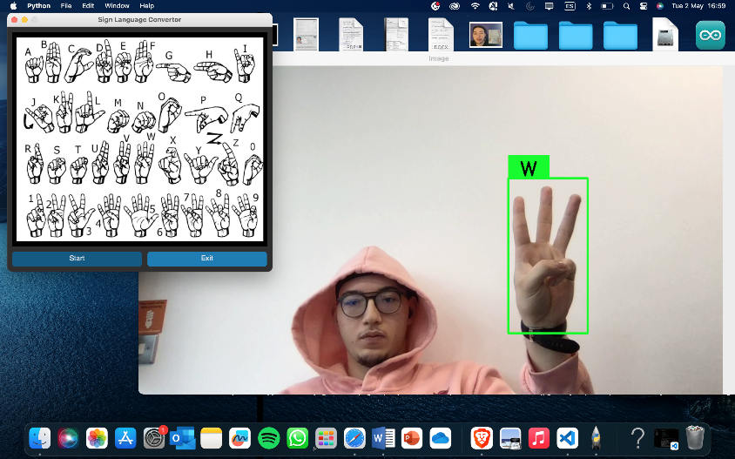

However, the software was mistakenly labeling my hand position, the ai application find it hard to detect my hand while performing 0 asl sign, ai system kept displaying the rectangle above the head:

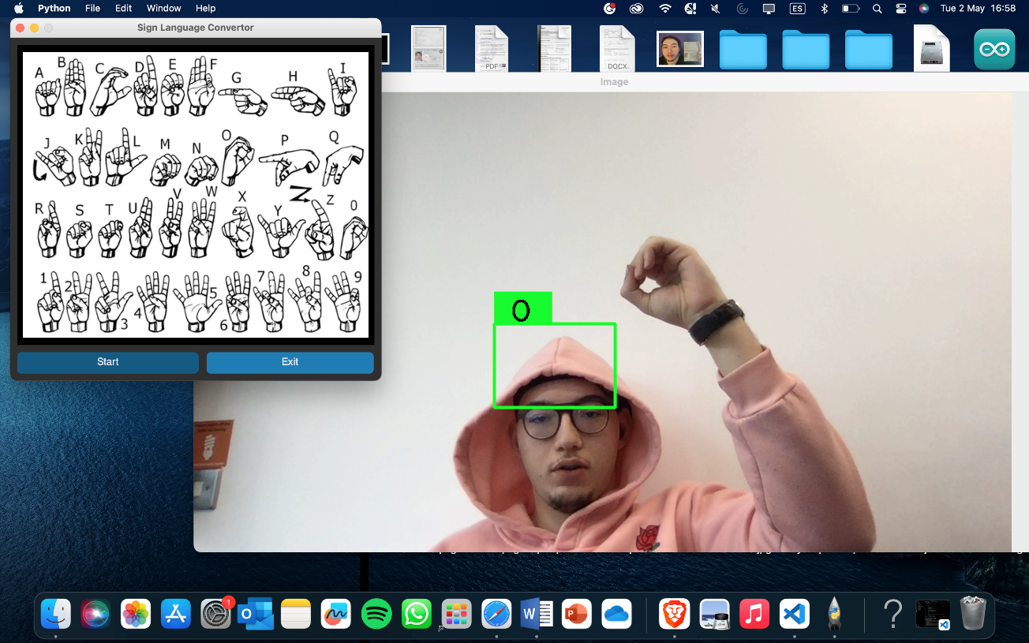

**IV.II issues and errors**

1. The AI application could not detect my hand while performing multiple signs in some scenarios: This issue could be due to limitations in the detection algorithm used by the AI application. Some algorithms may struggle to detect hands when they are positioned in certain ways or if there are obstructions such as clothing or other objects.
2. The sign language detector did not manage to display the correct label to multiple ASL signs, 7 attempts out of 18 to be precise: This issue could be due to the limited training data used to train the AI application. it may struggle to accurately recognize some signs.
3. The sign language detector did not manage to track my hand if I am moving it fast, on other occasions the ai application breaks and restart: This issue could be due to limitations in the motion tracking algorithm used by the AI application.
4. The sign language detector does not display the answer spontaneously: This issue could be due to the design of the AI application.
5. The AI application could not detect the signs that require movements: This issue could be due to limitations in the detection algorithm used by the AI application.

**IV.III strengths and weaknesses**

The sign language detector managed to respond correctly in these scenarios 61.11%

- Analyze the results and identify any patterns or trends in the data

- Identify any strengths and weaknesses of the AI application based on the test results

1. **Recommendations**

Increasing the amount and diversity of training data could help to improve the accuracy of the model.

Improving the detection algorithm could help to address this issue.

Improving the motion tracking algorithm could help to address this issue.

Redesigning the application to display the label or answer in real-time could help to address this issue.

- Create a set of recommendations based on the results

- Provide practical solutions for addressing the weaknesses and improving the strengths

- Suggest ways to enhance the AI application's accuracy, speed, and user experience

- Identify potential future improvements that could be made to the AI application

1. **Conclusion**

- Summarize the key findings and conclusions of the report

- Emphasize the importance of testing the AI application to ensure its performance and reliability

- Provide final thoughts and suggestions for future testing and improvements